SENTIMENT ANALYSIS REPORT:
Sentiment Analysis of X (Twitter) Data
1. Introduction
Social media platforms like X (formerly Twitter) generate vast amounts of user opinions daily. Analyzing this data helps understand public sentiment, trends, and key concerns.
This project focuses on performing sentiment analysis on social media data to classify user opinions as positive, negative, or neutral and extract meaningful insights using data visualization.
2. Objective
The main objectives of this project are:
- To classify tweets into positive, negative, and neutral sentiment
- To perform data cleaning and preprocessing
- To create meaningful features for better analysis
- To build an interactive dashboard for visualization
- To extract insights from user-generated data
3. Dataset Description
The dataset consists of tweets collected from X (Twitter), containing:
- Text data (tweets)
- Sentiment labels:
  - 1 → Positive
  - 0 → Neutral
  - -1 → Negative
This dataset represents real-world social media content, including informal language, abbreviations, and noise.
4. Data Cleaning & Preprocessing
Data cleaning was performed using Python to ensure accuracy and usability.
Steps performed:
- Removed missing values
- Converted text to lowercase
- Removed URLs and special characters
- Created a cleaned text column
- Converted sentiment values into labels
5. Feature Engineering
Additional columns were created to enhance analysis:
- Sentiment → Converted labels (Positive, Neutral, Negative)
- Sentiment Score → Numerical representation (1, 0, -1)
- Word Count → Number of words in each tweet
- Text Length → Character count
- Issue Flag → Detects presence of keywords like "issue", "problem", etc.
These features helped in deeper analysis beyond basic classification.
6. Tools & Technologies Used
- Python (Jupyter Notebook) → Data cleaning & preprocessing
- Power BI Desktop → Dashboard creation
- Libraries:
  - Pandas
  - Matplotlib
  - WordCloud
7. Dashboard Overview
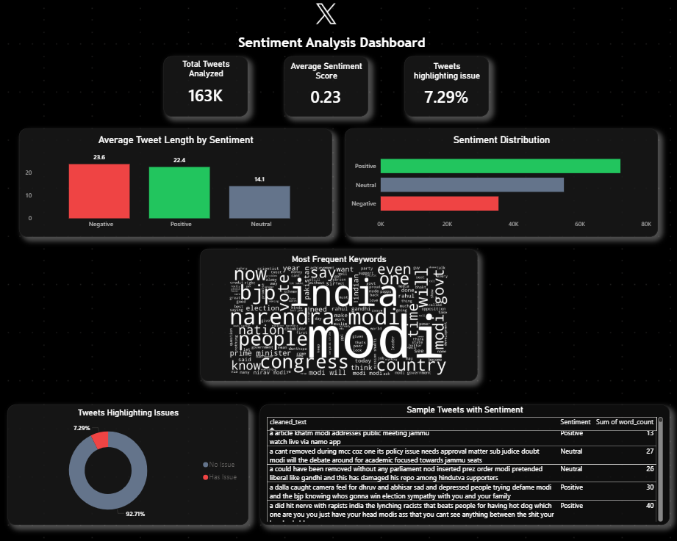
An interactive dashboard was created to visualize sentiment patterns and insights.
Key Visualizations:
- KPI Cards (Total Tweets, Avg Sentiment, Issue %)
- Sentiment Distribution (Bar Chart)
- Average Tweet Length by Sentiment
- Word Cloud (frequent keywords)
- Issue Analysis (Pie Chart)
- Tweet Table (detailed view)
8. Key Insights
- Majority of tweets show positive sentiment, indicating overall favorable opinion
- Negative tweets tend to have higher word count, suggesting detailed complaints
- A portion of tweets highlights recurring issues
- Frequently used words reveal trending topics and concerns
- Neutral tweets indicate areas where users express less strong opinions
9. Conclusion
This project demonstrates how sentiment analysis can be used to understand public opinion from social media data.
By combining data preprocessing, feature engineering, and visualization, meaningful insights were extracted that can help in decision-making and improving user experience.
10. Future Scope
- Use advanced NLP models like BERT for better accuracy
- Perform real-time sentiment analysis
- Analyze sentiment trends over time
- Expand dataset for deeper insights

